

Under the Big Top

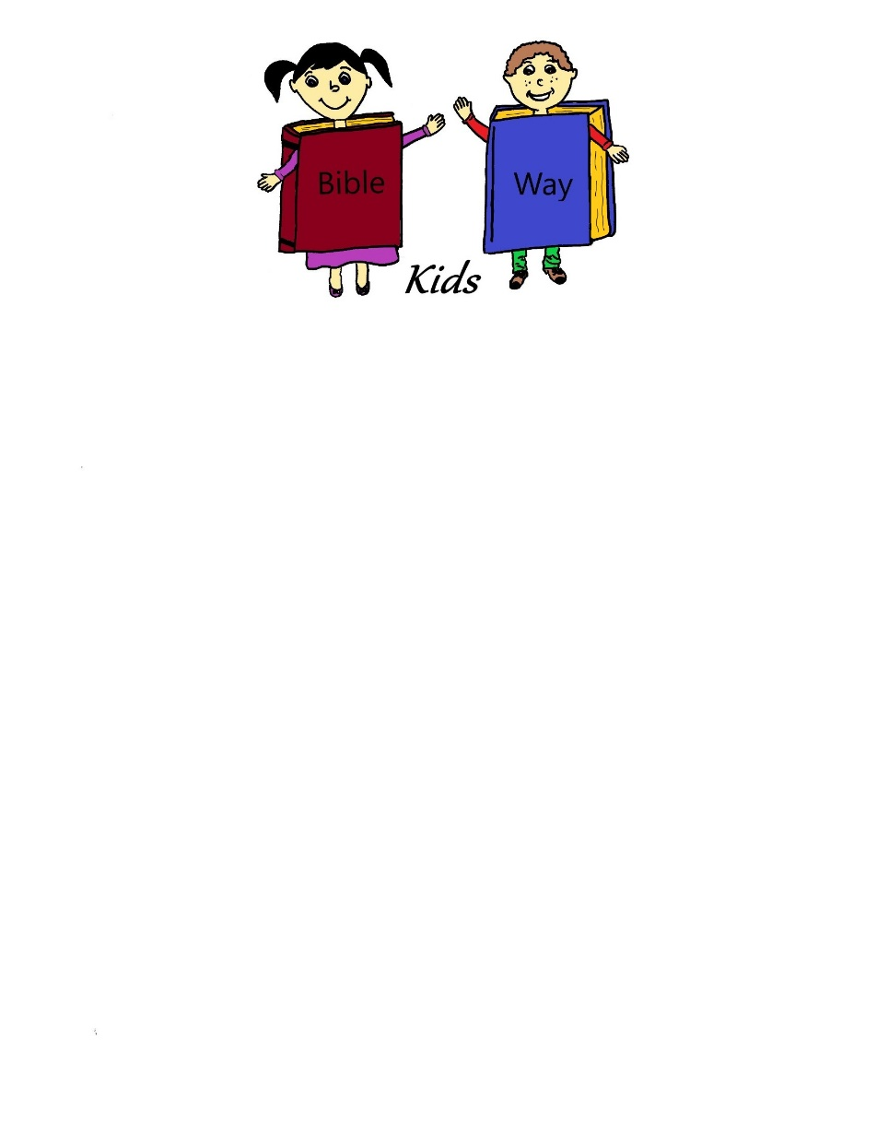  
A Bible-Way Kids curriculum compiled by:  
Heritage Family Church   
3840 N. Seneca, Wichita, KS 67204   
316-942-6652



Under the Big Top

**Table of Contents**

Lesson One: The Strong Man-Samson

Lesson Two: The Tall Man- David and Goliath

Lesson Three: The Short Man-Zacchaeus

Lesson Four- The Man Swallowed by a Fish-Jonah

Lesson Five: The Lion Tamer-Daniel and the Lion’s Den

Lesson Six: The Fire Defeaters-The Three Hebrew Children

Lesson Seven: The Circus Animals-Noah’s Ark

Lesson Eight: The Talking Donkey-Balaam

Lesson Nine: The Acrobat-Peter Walks on Water

Lesson Ten: The Tumbling Walls-Joshua at Jericho

Lesson Eleven: The Spotted Men-Jesus heals Ten Lepers

Circus Day-Ideas



**Under The Big Top**

**Lesson One  
The Strong Man: Samson**

**Lesson at a Glance**

**Lesson Text:** Judges 16

**Memory Verse:** Psalm 18:1

**Welcome and Attendance:** Attendance sheets and tickets (May make own tickets or purchase a roll from a party store) Make the tickets duplicate or purchase duplicate. Cassette or CD player with circus music playing.

**Offering:** Circus Bank (Circus animal bank)

**Pre-session:** Small weights, inflatable floaties that go on the arm

**Story:** 3 mops, 2 small brooms, large pair of scissors, see Resource for faces

**Memory Verse:** Seven pieces of cardstock with pieces of the memory verse written on them

**Song Chart:** Make a chart with large sheets of paper attached together or purchase a flip chart to print songs each week

**Craft:** Two tootsie rolls suckers per child, masking tape

**Game:** No materials needed

**Drawing:** Small prize for ticket drawing. A circus related prize will be needed for each week’s drawing: cotton candy, circus peanuts, animal crackers, etc…

**Under The Big Top**

**Lesson One  
The Strong Man: Samson  
Scripture Text:** Judges 16 **Memory Verse:** Psalm 18:1 “I will love thee, O Lord my strength.”

**Welcome and Attendance:** (5 minutes) Each child receives a ticket as they enter at the ticket booth. This will be used for a drawing at the end of the session.

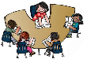**Pre-session:** (10 minutes) Have small sets of weights available to show the children. Let them try to lift the weights, telling them to be careful with them. Talk to them about how much each weight weighs and what muscles we use when we lift them. Show them the “muscles” you have-after placing the inflatable floaties on your arms under your sleeves. Encourage them to make their own muscles by flexing their arms.

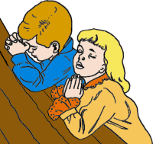**Prayer:** (10 minutes) Ask the children if any of them have prayer requests and pray with them. Some of them will never know what prayer is unless we show them. It doesn’t have to be a long prayer, but try to be sure to mention each child’s need.

**Offering:** (5 minutes) Let the children know that each week there will be a bank to place their offering in. You could change the animal or bank as often as you choose to keep it fun for the children. You could even keep the bank for one month and change it out and have a contest for the children to see which circus animal has the largest offering. Always encourage the children to bring an offering for Jesus, even if they only have a penny. We’re teaching that God loves a cheerful giver and teaching them at a young age the importance of giving.



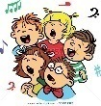**Songs:** (10 minutes) “My God is so big, so strong and so mighty”

“He’s got the whole world in His hands”

“God is so good”

Talk to the children about singing with a strong voice. Show them how to take a deep breath and sing out with a loud voice. God loves our strong voices.

**Memory Verse:** (10 minutes) Use the seven pieces of cardstock with the memory verse broken up and written on them. Each sheet will only have a part of the memory verse written on it. Line up seven children side by side with each having a piece of cardstock. The other children in the group will sit in front of them. The children all begin with their pieces of cardstock facing outwards and the memory verse is read. Each time the memory verse is read a piece of the verse is turned over. This way the memory verse is read at least seven times. By the last turn-over the children will be reciting the verse from memory. (If you have less than 7 children you can put more words on each cardstock or tape the cardstock on a wall and turn the sheets over the same way as if the children were holding them).

**Craft: (**10 minutes) Give each child two tootsie roll suckers and a piece of masking tape about two inches long. Have them place the suckers end to end and then slide them together side by side. Put the tape around them. They now have a set of barbells to eat later.

**Story:** (15 minutes)Our story today is about a strong man named Samson. Samson was a very strong servant of God-as long as he followed God’s instruction. God’s instruction to Samson was that he was not to cut his hair and not to tell anyone how he was so strong. (Introduce Samson mop). Isn’t he handsome, and has such lovely hair. Those seemed like silly instructions, but not to God. I think God was testing Samson to see if he would obey.

One day, Samson met a very beautiful lady named Delilah (Introduce Delilah mop). Samson thought she was so beautiful and he fell in love with her. *(Whisper)-But she really didn’t love Samson back, she just wanted to trick him and let him be captured by his enemies.* (Use Delilah mop) ”Oh Samson, you are so…ooo handsome and strong, please tell me where you get your strength from.” At first Samson didn’t tell her (Shake Samson mop head no). But she kept asking him and giving him little kisses (Delilah mop kisses Samson mop), finally he told her. “Delilah, if you cut my hair, I will be as weak as any other man.” So that night while Samson was sleeping, Delilah cut his hair. (Cut mop hair off of Samson mop with scissors) Then she called his enemies. The enemy came (bring in two small brooms with faces) and captured Samson and poked his eyes out and put him in prison. (poke out eyes of Samson mop and put it away) He was now blind and his heart was broken. I don’t know how long Samson was in prison, but his hair began to grow back out. (Show the second Samson mop with long hair)

One day his enemies brought him out before a large crowd, so they could make fun of him. He was placed beside some big pillars that held up the roof of the place. Samson prayed and one more time God gave him tremendous strength. The pillars fell and crushed Samson and all the people who were in the place.

How sad for Samson. If he had only listened and obeyed God, he would not have lost his life like that.

We need to make sure we obey God, our parents, our pastor and our teachers. We need to make sure we obey God’s Word and be ready to go to Heaven. We need to repent, be baptized in Jesus’ name and receive the Holy Ghost.

Pray with the children and encourage them to seek God.

**Drawing:** Using the tickets that have been taken at Welcome, pick a winner for the prize. The prize should be age and circus appropriate. Ideas could be cotton candy, candy peanuts, circus related toys etc…The drawing can be done at the end of the session or anytime that it is appropriate.

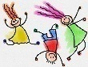**Extended Time Game:** Played the same as Simon says, except the name Samson says is used. The children are lined up against a wall with another wall or line that they are going to. The children are given directions, but are only supposed to do them if the leader says “Samson Says” before the instruction. Those that follow the direction that is given without the words “Samson Says” have to go back to the beginning. The first child to get to the finish wall or line following the directions correctly is the winner. Example: Samson Says take two large steps. All children are to take two large steps. Take two small steps, no children should take steps, if they do they have to go back to the beginning.



**Under The Big Top**

**Lesson Two  
The Tall Man: David and Goliath**

**Lesson at a Glance**

**Lesson Text:** I Samuel 17

**Memory Verse:** I John 4:4

**Welcome and Attendance:** Duplicate tickets

**Pre-session:** Cardboard boxes, enough to measure 9 ft. when stacked

**Offering:** Circus bank

**Songs:** Song chart with new songs written

**Craft:** watercolors, 5 small smooth rocks per child, 1 larger rock per child, black sharpie, brown paper bags, crayons

**Memory Verse:** Duplo blocks, poster board or dry erase board with memory verse written, two brown bags, small candy for prizes

**Story:** Cardboard boxes used in pre-session, one cardboard box with mean face, soldier hat, tape measure, bag of stones, sling shot, black electrical tape

**Extended Time Game:** Black tape, bags of stones

**Drawing:** Tickets

**Under The Big Top**

**Lesson Two  
The Tall Man: David and Goliath  
Lesson Text:** I Samuel 17  
**Memory Verse:** I John 4:4 “Ye are of God, little children and have overcome them: because greater is he that is in you, than he that is in the world.”

**Welcome and Attendance:** (5 minutes) Write each child’s name on a ticket for the drawing.

**Pre-session:** (10 minutes) Have a group of boxes for the children to stack. Ask them to build them as high as they can. Can they make them four feet tall, five feet, what about nine feet? Talk to them about how tall they are and how tall nine feet is.

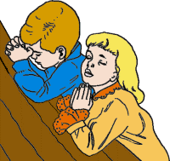**Prayer:** (10 minutes) Talk to the children about the great power and majesty of God. He can do anything!! Take prayer requests today-building a faith in God with the children. Thank God for all the things He has done and let them know He can answer their prayers.

**Offering:** (5 minutes) Have an offering container set up high enough that the children have to reach to put in their offering.

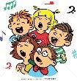**Songs:** (10 minutes) “Only a Boy Named David”

“My God Can Do Anything”

Children’s choice

Have children stand to sing. Have them stand on their tiptoes while singing one of the songs. Be sure to do actions for David song. (if you don’t know them you can make them up)

**Memory Verse:** (10 minutes) Write the memory verse on a poster board or dry erase board and have it where the children can reference it. Using large Duplo-like building blocks (these are like Legos only larger), write the memory verse in segments on several of the blocks. Make two sets. Example: **Ye are of God little children and have overcome them, because greater is he that is in you than he that is in the world. I John 4:4**

(You can use as many or as few blocks as you choose based on the age you are teaching.) Place a set of blocks in each of two paper bags and divide the children into two teams. At the go signal the children work as teams putting the blocks together to form the memory verse. The first group getting it together correctly wins. Have a small prize (piece of candy, etc..) for each one on the winning team. Play as many times as time allows.

**Craft:** (10 minutes) Make David’s bag of stones. Give each child five smooth stones to paint with watercolors. (younger children may need paint shirts). After the rocks dry, write the letters J-E-S-U-S, one letter per rock, with a black sharpie. Paint one larger rock and mark it with the letter G. Let the children decorate a small brown paper bag to place their rocks in. Twist the tops closed.

**Story:** (15 minutes) Let the children help carry the boxes you used in pre-session to the story area and stack them on the floor.

We talked earlier about how tall nine feet was. Have you ever seen anyone that tall before? There was a man in the Bible that was that tall!! His name was Goliath. (Read I Samuel 17:4) A cubit equals 1 ft. 6 in. and a span is 9 in. That made Goliath 9ft 9 in. tall. Use the tape measure to measure that height on the wall, (may have to stand on a chair) Mark the measurement with a piece of black tape and let the children stack the boxes and then add the Goliath head and helmet.

Goliath was a Philistine and they were enemies of God’s people, the Israelites. He came out every day and challenged them. “Send me a man to fight me”, he said. But the Israelites were all afraid of him and ran from him.

Out in a field taking care of sheep was a young boy named David. (choose one of the young boys in the class) He had protected the sheep and had killed a bear and a lion who had threatened them. His father sent him to take bread to his brothers who were in the battle against the Philistines. When David got there he saw what was going on and it made him MAD!!! How dare this Goliath defy the army of the living God? David said, “I will go and kill this Goliath”. Do you think he went and put on lots of armor and a big helmet?? He probably would need a big sword!! Nope, not David. He went to a small brook nearby and found five smooth stones and put them in his pocket with his slingshot and went out to meet the giant. (Let the young boy put the items in his pocket)

What do you think Goliath did? He laughed and thought it was a joke that the Israelites had sent David. He mocked David and the one true God. David pulled out his slingshot and a stone and slung it at Goliath. (Let the young boy hurl a stone at the cardboard box Goliath, use your foot to knock it over). The rock hit the giant in the middle of his forehead and he fell face down to the earth dead!!

Did David defeat the giant with his own Power? I don’t think so either, God gave him the victory. That’s how we can defeat the devil and sin every time, by having God go with us. We’ll always be winners.

How do we make sure we have God fighting on our side? That’s right! By having his spirit living in us. The Holy Ghost is God’s spirit living in us. We need to repent (tell God we’re sorry for the wrong things we’ve done), be baptized in Jesus’ Name and be filled with the Holy Ghost. Let’s pray and ask God to fill us with the Holy Ghost. Have an altar call with the children.

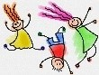**Extended Time Game:** Play a game with the rocks that have been made. Tape a square on the floor or outside on the sidewalk (weather permitting). Using a set of the rocks, place a Goliath-G rock in the middle of the square. Let the children take turns sliding the rocks to knock the Goliath rock out of the square. You can make more than one square and have a few games going on based on how many teachers and children you have with your group.

**Drawing:** Use tickets to draw circus prize.

**  
Under the Big Top  
Lesson Three  
The Short Man: Zacchaeus**

**Lesson at a glance**

**Lesson Text:** Luke 19:1-10

**Memory Verse:** Luke 9:10

**Welcome and Attendance:** Attendance sheets and duplicate tickets that have numbers. Cassette or CD player with circus music

**Offering:** Circus Bank (Circus animal bank)

**Pre-session:** Cardstock, red marker, scissors

**Craft:** two empty toilet paper rolls per child, decorative duct tape, glue sticks, hole-punch, yarn

**Memory Verse:** poster board or dry erase board and marker, word search with hidden memory verse words

**Story:** Zacchaeus story cards from Resource section. Glue story readings onto the backs of the images.

**Under the Big Top**

**Lesson Three  
The Short Man: Zacchaeus  
Lesson Text:** Luke 19:1-10 **Memory Verse:** Luke 9:10 “For the Son of man is come to seek and to save that which was lost.”

**Welcome and Attendance:** (5 minutes) Each child receives a ticket as they enter at the ticket booth. This will be used for a drawing at the end of the session.

**Pre-session:** (10 minutes) Make puzzles today. Draw hearts on cardstock and write the word Zacchaeus on them, one per child. Draw puzzle lines on the heart and let the older children cut out their own puzzles along the lines. With younger children cut the puzzles in advance. Let the children work together or in twos putting the puzzles together. Talk about how Zacchaeus had a change of heart when he met Jesus.

**Prayer:** (10 minutes) We are teaching today about a changed heart. Talk to the children about God doing that for us. How do we get a changed heart? By repenting and asking God to change us to be new creatures. Pray with each one of the children, asking God to help them to be different and not do wrong things. We sometimes have to simplify things for the children. We want to bring salvation down to where they can understand and seek God.

**Offering:** (10 minutes) Let the children know that each week there will be a bank to place their offering in. You could change the animal or bank as often as you choose to keep it fun for the children.

**Songs:** (10 minutes) “Zacchaeus Was a Wee Little Man”

“Change My Heart, Oh God”

**Memory Verse:** (10 minutes) Write the memory verse on poster board or dry erase board. Make copies of the word search and ask the children to find the hidden words. After they have found the words help them to put them in order to write the memory verse. They can look at the verse while writing their own if they need help. The younger children will need help with this. Perhaps sing a song with the memory verse.

**Craft:** (10 minutes) Make binoculars today. Give each child two empty toilet paper rolls and use decorative duct tape to decorate them. Use a glue stick to glue the rolls together and then duct tape the two rolls together to form the binoculars. Use a hole-punch to make a hole on each side of the binoculars (the outside of each roll) and tie the end of an 18-20 inch strand of yarn through each hole. The yarn should be long enough to hang loosely around the children’s necks. Let the children pretend to look up high to see Zacchaeus. Ask them if Jesus needed binoculars to see him. He was hiding but Jesus didn’t need binoculars. Why not? Because Jesus is God and He knows and sees everything and everyone.

**Story:** (15 minutes) Ask the children to stand up. Who is the shortest person in our class today? Ask the child to come to the front and stand by you and then stand up. Which one of us do you think could see over a large crowd the easiest? Of course, I could, because I’m taller. There’s nothing wrong with being short, is there? Only problem is if you want to see something sometimes. The man in our story today, Zacchaeus, was very short. He had the job of a tax collector. That means people had to go to him to pay what they owed the government. The problem with Zacchaeus was that he was greedy and he took more money from the people than he should have and no one liked him. Let’s look at the story cards and see if we can figure out what happened to him. (Read the back of each story card as you show the picture on the front) Pray with the children after explaining the plan of salvation with them.

**Extended Time Game:** Play the game “I Spy”. One child will say “I spy, with my little eye something that is blue” the other children have to guess what the child has “spied”. The child who guesses correctly gets to spy something next. They can choose any color of item they want. (Sometimes the children will change what they have spied after someone guesses it, so you may need to lend a little supervision.)

**Drawing:** Draw the ticket for the prize before going home.



**Under the Big Top**

**Lesson Four  
The Man Swallowed By A Fish: Jonah**

**Lesson at a glance**

**Welcome and Attendance:** Duplicate tickets

**Pre-session:** Envelopes, 5cut-out construction paper fish per child, paper clips, string, pencils, small magnets

**Offering:** small fish bowl with water, small cup, extra coins

**Craft:** brown paper bags painted blue, stuffing (shredded newspaper or stuffing), masking tape, blue construction paper, flippers for each child, blue rectangle for spout, glue, wiggle eyes, crayons

**Story:** gold fish bowl with one gold fish

**Drawing:** tickets in bowl, fish bowl and fish if using for drawing-circus prize if not

**Under the Big Top**

**Lesson Four  
The Man Swallowed By A Fish: Jonah  
Scripture Text:** Jonah 1-3 **Memory Verse:** Psalm 85:8 “I will hear what God the Lord will speak.”

**Welcome and Attendance**: (5 minutes) Each child receives a ticket as they enter at the ticket booth. This will be used for a drawing at the end of the session.

**Pre-session:** (10 minutes) Give each child an envelope with several construction paper fish, with paper clips on the nose of each one. Help the children tie a piece of string onto the end of a pencil eraser and a magnet on the other end of the string. Scatter the fish onto the table and let the children try to “catch” their fish. Play the game until time for the session to begin. (Prepare finished games for children to take home that do not arrive early.)

**Prayer**: (5 minutes) Talk to the children about the meaning of obedience and help them to pray today for God to help them be obedient. We want them to learn the importance of responding in a positive manner when told to do something, without complaining or whining. If we teach the importance of obedience now while they are young, they will obey those that have the rule over them, including parents, pastor, teachers and most of all God.

**Offering:** (10 minutes) Use a small fish bowl with water for the offering container today. Place a small cup in the middle of the bowl and let the children drop their coin offerings into the bowl and try to get them into the cup. For those with paper bill offerings have enough coins on hand to make change for them. For those with no offering give them a chance to try one coin.



**Songs:** (5 minutes)

Who did, who did swallow Jonah?

The BIBLE

Jesus Loves Me

**Memory Verse:** (10 minutes) Teach the memory verse using gestures:

I will (point to self)

hear (cup ear)

what God the Lord (point up)

will speak (point to mouth)

Allow each child to say the memory verse by themselves.

**Craft:** (10 minutes) Stuffed paper bag whale: Stuff paper bag with stuffing material leaving about 3 inches unstuffed. Scrunch the top together and wrap masking tape around to seal. The stuffed part is the body of the whale. The end (top of the bag) is the tail. Cut flippers from blue construction paper. Glue them to the bottom of the whale leaving them sticking out. Cut out a rectangle from the blue construction paper and cut slits on each end of it. Roll the piece around a pencil and tape it to make a tube (the spout of the whale). Poke a hole in the top of the bag with a pencil and squish the bottom of the spout in and tape as needed. Glue on wiggly eyes and draw on a nose.

Optional: The children can draw a paper Jonah and stuff him in the whale. The children will then know Jonah is “trapped” inside the whale.)

**Story:** (15 minutes) Bring a gold fish bowl with one gold fish in it. (This can be given away for the drawing if you desire.)

How many of you have ever owned a fish? What kind of fish did you have? What color was it? Do you see this fish bowl? (show the fish) This one should be easy to care for. It’s small and it lives by itself in the bowl. This is a very small fish compared to some fish that live in the ocean. Did you know there are fish in this world that are really huge? For instance the Great Blue Whale can be 95 ft long and weigh over 100 tons. That’s 200,000 pounds. Its heart can weigh 1,000 pounds. That is one big fish!!!!

The Bible tells a story about a man who was swallowed by a big fish. We know it’s true because “the Bible is always true”. Do any of you know his name? That’s right. It was Jonah.

Jonah loved God and he was a preacher. One day God asked him to do something that was very scary to Jonah. God told him to go to a very evil town called Ninevah and preach to the people there. Jonah did not want to go there. (Whisper) the people were so mean there that they would kill people and hang their bodies on the wall of the city. Nope, Jonah did not want to go there. He should have trusted God to take care of him, but instead he ran away.

Jonah got into a ship headed the other way from Ninevah and hid himself deep down inside the ship. Do you think he was hidden from God??God knew exactly where Jonah was.

It wasn’t long before a big storm arose and tossed the ship all around. The men began throwing things off the boat. Finally someone spotted Jonah. Jonah was honest and told them the storm was his fault. He knew God was angry at him for running away. The men decided to throw Jonah overboard because they feared for their lives. Almost as soon as he was in the water he was swallowed by a big fish and guess what happened to the storm? You’re right, it stopped. But what happened to poor Jonah? He was inside the belly of a stinky, smelly old fish.

Pee…ewww. There he sat for three days with nothing to do but think, and think, and think.

He decided if he ever got out of that stinky place he would go to Ninevah and preach. What do you think happened next? As soon as he decided that, God caused that big fish to get sick, he threw Jonah up onto the beach. Super Yuck!! Jonah probably didn’t smell very good and he had fish yuck on him, but he went straight to Ninevah and told the king and the people about God. The king and the people listened to Jonah. The king ordered everyone to believe in the God of Jonah, the one true God.

What a great story. The Bible is such an exciting book!!

You see boys and girls, God has a plan for each of our lives and we need to obey Him. We need to repent, be baptized in Jesus Name and be filled with the Holy Ghost. That’s God’s plan for each of you. Pray with the children as they seek God

**Extended time Game:** (15minutes) Line all the children up along the wall and have a mark on the other side of the room that they are to run to. One child is the whale in the middle. When the “whale” says “Jonah, Jonah, come to me, all the children try to get across the room to the other side. The “whale” tries” to tag as many of the children as he can as they move across. If anyone is tagged they become a whale too and helps to catch the children as they move across the room the other way. The play continues until all the children are “whales”

**Drawing:** (10 minutes) A ticket may be drawn for the fish and bowl in the story if you choose or another “circus” type prize.



**Under the Big Top**

**Lesson Five  
The Lion Tamer: Daniel and the Lion’s Den**

**Lesson at a Glance**

**Welcome and Attendance:** Duplicate tickets

**Pre-session:** A sturdy board with a lion’s head drawn on it with the mouth cut out.

3-4 bean bags

**Offering:** Lion bank (if available), if not circus type bank, stuffed lion

**Craft:** Plain cupcakes, yellow frosting, plastic knifes, mini M&M’s, black tube icing, caramel corn

**Memory Verse:** Poster board or dry erase board and marker, lion coloring sheet, crayons, yellow yarn cut into small pieces, glue.

**Story:** Boat oars

**Drawing:** tickets, prize for drawing

**Under the Big Top**

**Lesson Five  
The Lion Tamer: Daniel and the Lion’s Den  
Scripture Text:** Daniel 6  
**Memory Verse:** Joshua 23:10 “…the Lord your God, he it is that fighteth for you, as he hath promised.”

**Welcome and Attendance:** (5 minutes) Each child receives a ticket as they enter at the ticket booth. This will be used for a drawing at the end of the session.

**Pre-session:** (10 minutes) Ahead of time prepare a board with a lion’s face with the mouth cut out. Let the children throw bean bags into the lion’s mouth.

**Prayer: (**10 minutes) Ask the children if they have ever been afraid of anything. You’re sure to get lots of answers. Discuss with them some common fears and tell them the story today is about a young man who might have been afraid but still trusted God to take care of him. Pray with the children about their fears and ask God to help them.

**Offering: (**5 minutes) If possible use a lion bank for the offering. If not, use the offering container that has been in use in previous sessions. Have a stuffed lion on hand beside the offering and let the children growl every time an offering is placed in the container.

**Songs:** (10 minutes) “If you’re happy and you know it”

Children’s choice

“All God’s children love the Holy Ghost”

**Memory Verse:** (10 minutes) Write the memory verse on a poster board or dry erase board. Give each child a lion sheet, crayons and yellow yarn cut into small pieces. Let the children complete the lion sheet coloring and gluing on the yarn on the lion’s mane while you teach them the memory verse in song. You can pick any tune you like and add the words of the memory verse. This is a very effective way to teach God’s word. Example: (Tune of Twinkle, Twinkle Little Star: The Lord your God, fights for you, just as he has promised. (For older children you can add the first part of this verse)

**Craft:** (10 minutes) Bring plain cupcakes for the children to decorate and make into lions. The children can frost the cupcakes with yellow frosting. Use mini M&M’s for the eyes and use tube icing to drawn on nose and mouth. Complete the lion with caramel corn around the edges of the cupcake for the mane. Let the children eat their lions!!

**Story: (**15 minutes) (Use a set of boat oars to help tell the story)

Do you know what these are? (Show the oars) That’s right, these are boat oars. We use them to help us steer our boat when we go out in the water. Have you ever heard this song? (Sing, Row, row, row your boat). Let’s sing it together, I’ll help you. That was great!

Let’s think about the words of that song. It says to row gently down the stream. That isn’t always possible. Sometimes you have to row hard (demonstrate with the oars), to get where you want to go. The water sometimes is going against you.

Our bible story today is about a man named Daniel who had to go in a different direction than those around him.

Daniel was a servant of King Nebuchadnezzer. Daniel like the king and the king liked him. Daniel was very dedicated to God and served him only as the one true God and he prayed to God three times a day.

One day the king made a rule. He didn’t want anyone to pray to any god or man except him. No one was allowed to bow down to any other God or leader. If they were caught they would be thrown into a den with hungry lions.

Do you think Daniel was afraid? Maybe a little but he knew that no matter what God came first in his life. He refused to bow down to anyone but God. The next day Daniel didn’t change his prayer times. Oh no, he got up and began to pray just like every other day. Some bad guys ran and told the King what Daniel had done. The king was very sad because he liked Daniel and did not want to throw him into the den with the lions, but because of the law he had made he had to do just that.

Poor Daniel!!! Do you think he would be eaten by those lions? The king thought so. He couldn’t sleep all night. As soon as the sun came up he went straight to the lion’s den and called out “Daniel, are you all right?” He really didn’t expect an answer because he thought Daniel would be eaten by the lions. All of a sudden he heard a voice, “I am here, oh my king”. The king was so surprised!! He immediately had Daniel pulled out of the den. “How are you still here?” the king said. Daniel told him that God has sent an angel to close the mouths of the lions. The king began to praise Daniel’s God. The king commanded everyone to worship the one true God of Daniel.

Someday you might have to make a decision to follow God’s laws or follow man. We need to make sure that we always do what God wants us to do. We need to always obey God. What is the plan of salvation that God wants us to obey? That’s right, repent, be baptized in Jesus name and be filled with the Holy Ghost with the evidence of speaking in other tongues. Let’s all pray together. Give altar call and pray with the children.

**Extended Time Game**

Lion, Lion, Daniel-this is a variation of Duck, Duck, Goose. All the children are seated in a circle with one child being “Daniel”. Daniel goes around the circle tapping each child on the head and saying lion, lion, lion until he says Daniel and that child jumps up and chases the “Daniel” around the circle back to that spot. If the child catches the origin “Daniel” they become the new “Daniel”. If they don’t catch “Daniel” they go to the middle of the circle or to the side and sits down for two games. Game continues until all the children have had a chance to play.

**Drawing:** Draw ticket for the prize.



**Under the Big Top**

**Lesson Six  
 The Fire Defeaters: The Hebrew Children**

**Lesson at a Glance**

**Welcome and Attendance:** Duplicate tickets

**Pre-session:** Coloring sheets, crayons

**Offering**: Offering container, tea light

**Craft:** Red cellophane, stryofoam cup, red confetti, glue, craft sticks, markers

**Memory Verse:** Puppet of choice, karaoke, poster board or dry erase board and marker

**Story:** Color story pictures and cut out. On a long roll, glue the story pictures on one side of the roll and the coordinating story card on the other side. As you unroll the roll you can tell the story

**Under the Big Top**

**Lesson Six  
The Fire Defeaters: The Hebrew Children  
Scripture Text:** Daniel 3:1-30  
**Memory Verse:** Psalm 46:1 “God is our refuge and strength, a very present help in trouble.”

**Welcome and Attendance:** (5 minutes) Children will receive ticket for drawing at end of session at the ticket booth.

**Pre-session:** (10 minutes) Let children color choice of coloring sheets or both if time allows

**Prayer:** (10 minutes) Talk about the dangers of fire. Can fire be a good thing also? One fire that is good is the fire of the Holy Ghost. Explain how when we receive the Holy Ghost our souls catch on fire and we burn brightly for God. This will be a strange concept for some of the children and will need to be explained. Pray with the children and ask God to fill them with the Holy Ghost.

**Offering:** (5 minutes) Let the children give their offering and try to blow out the tea light that is sitting next to the offering. They will have fun trying.

**Songs:** (10 minutes)

Give me oil in my lamp

I wish somebody’s soul would catch on fire

This little light of mine

**Memory Verse:** (10 minutes) Use a puppet and the karaoke to help the children learn their verse today. Write the memory verse on a poster board or a dry erase board. Let the puppet read the memory verse several times, making mistakes and letting the children correct. Say the verse together as a group a few times and then let the children say the verse into the karaoke. If you have playback, play the children back saying the verse.

**Craft:** (10 minutes) Let children glue strips of red cellophane around a styrofoam cup to represent the fiery furnace. Place a small amount of red confetti in each cup for the fire. Give each child four craft sticks. Help them draw faces on the sticks and place them in the furnace. Ask the children if any of them have seen fireplaces? Relate how a furnace looks like a fireplace, but much bigger and much hotter.

**Story**: (15 minutes) Using the story roll that has been made before class, tell the story of the Three Hebrew Children. God always comes through for those that love Him. Those Hebrew children had to make a very hard decision, but like Daniel last week, they chose to trust God and not to bend or bow. That’s the way we need to be. Trust in God to take care of us, even when it’s a bad situation. God is always faithful. That means he will always take care of us.

Let’s see if you remember the plan of salvation. Repent, be baptized in Jesus Name and be filled with the Holy Ghost. Talk to the children in depth what the plan of salvation means and pray with each of them.

We repeat the plan of salvation weekly because this is something we don’t want them ever to forget. If this is the first and last time they ever attend our Children’s Church or if they ever stray from church and go another direction we want this to be planted somewhere in their spirit, so that God can deal with their hearts.

**Extended Time Game:** Reenact the story with the children letting them take turns being the Hebrew children, the king, the guards and the fourth man in the fire. You can bring costumes for them to use. The children enjoy “becoming” someone else and reinforces the story in their minds.



**Under The Big Top**

**Lesson Seven  
The Animals: Noah’s Ark**

**Lesson at a glance**

**Lesson Text:** Genesis 6-8

**Welcome:** Duplicate tickets, stickers for attendance

**Pre-session:** Poster board to make an ark, coloring page animals, tape, blindfold

**Offering:** Stuffed animals

**Songs:** Song Chart

**Craft:** One pattern of dove per child, glue, white feathers, pencils, crayons

**Memory Verse:** Poster board or dry erase board and marker, soft ball or beanbag

**Story:** Large brown grocery bag, mini plastic animals and people, sprayer bottle with water

**Extended Time Game:** Stuffed animal, tape or cd player

**Drawing:** Prize for drawing

**Under The Big Top**

**Lesson Seven  
The Animals: Noah’s Ark  
Scripture Text:** Genesis 6-8  
**Memory Verse:** Genesis 6:9 “These are the generations of Noah, Noah was a just man and perfect in his generations, and Noah walked with God.”

**Welcome and Attendance:** Give each child a ticket for the drawing at the end of the session and record attendance. Let children put sticker on attendance balloon

**Pre-session**: Using poster board ark and the coloring page animals, play a game of “Put the animal in the ark”. Put the ark on the wall. Put tape on the coloring page animals. Let children choose an animal to put in the ark. Blind fold them one at a time and let them try to stick the animal onto the ark.

**Prayer:** Let’s thank God for the animals today. Our story today lets us know God cared for the animals and the righteous people who took care of them. God made a way of escape for them.

**Offering:** Have several circus animals surrounding the offering container. As the children place their offering in container, let them tell you which animal is their favorite and why.

**Songs:** Use the song chart to help the children sing the songs.

“Who built the Ark?”

“The wise man and the foolish man”

“The B-I-B-L-E”

**Memory Verse:** Have the memory verse written on the poster board or dry erase board. The children should sit in a circle and one child is given a soft ball or beanbag. The child says the memory verse and then tosses the ball or bean bag to someone else in the circle who will then say the verse. Play is repeated until all the children have had a turn to say the verse.

**Craft:** Cut out attached patterns. (one pattern per child) Older children could cut out their own, younger children might need help. Trace the child’s hands on another piece of paper and cut out.

* Glue the head(circle) to the body (upside down)
* Let the children draw on the face
* Let the children glue on feathers to the top of the head
* Glue tail feathers onto the body
* Glue the feet onto the body
* Glue handprint wings on the back of the body
* Glue the flower on a wing or beside the neck

**Story:** Cut off top 12 inches of a large brown grocery bag. Draw a picture of the ark to the outside of the bag. Have available mini plastic animals and some plastic people and a sprayer with water.

Our story today is about a man named Noah. (Show plastic Noah) Quote with the children the memory verse for today. Noah loved God and God loved Noah. One day God told Noah to build a big ark. What is an ark? That’s right, it’s a big boat. Probably bigger than any boat you have ever seen. Noah was supposed to build that boat and take his family and all the animals into it. God told Noah he was going to cause it to rain for 40 days and 40 nights and flood the earth.

Do you know why God was going to do that? All of the people of the earth had become very wicked and didn’t love God. All except Noah and his family. It took Noah and his sons 120 years to build the boat. During that time Noah preached to all his friends and tried to get them to love God and be able to get on the boat, but they just laughed at him.

Finally the boat was done. (Show the sack with the ark). Noah started putting the animals on the ark. (Using plastic animals drop them into the bag as the children help you name them). After all the animals were in the ark, Noah and his family went in and God shut the door. (Roll over the top of the bag). It began to rain and rain and rain. (Have a helper use the sprayer to lightly mist the bag as you dip and turn the bag). It rained 40 days and 40 nights, just like God said it would. Everything and everyone that was not on the ark was destroyed. Finally, Noah sent out a dove to see if they could leave the ark. When the dove did not return they knew it was safe to leave the boat. Everyone came out of the ark and worshipped God. God sent a beautiful rainbow as a sign that he would never destroy the world with water again. Every time you see a rainbow after it rains you can remember that God keeps his promise.

Noah and his family were saved because they obeyed God’s word. How can we be saved? That’s right, we must repent, be baptized in Jesus name and be filled with the Holy Ghost. Let’s all pray together.

**Extended Time Game:** Musical Ark- The children sit in a circle and pass a stuffed animal around while music plays. When the music stops the child holding the stuffed animal goes to sit in the circle or on the side line. Play continues until only one player is left holding the stuffed animal.

**Drawing:** Use tickets to draw circus prize winner. A stuffed animal would be appropriate or you could give away people and animals used in the story.



**Under The Big Top**

**Lesson 8  
The Talking Donkey: Balaam**

**Lesson at a glance**

**Welcome and Attendance:** Tickets and stickers for attendance

**Pre-session**: Pin the tail on the donkey game, blind fold

**Offering:** circus bank or donkey bank

**Songs:** Song chart

**Craft:** donkey pattern, card stock, colors, google eyes, white paper for teeth, black yarn, large craft sticks

**Memory Verse:** Poster board or dry erase board and marker,

**Story:** Felt board, copies of story figures with felt glued on backs of them

**Extended Game Time**: tape player or cd player, music tape or cd,

**Drawing:** Tickets and circus prize

**Under the Big Top**

**Lesson 8  
The Talking Donkey: Balaam  
Scripture Text:** Numbers 22 **Memory Verse:** Jeremiah 42:6 “Whether it be good, or whether it be evil, we will obey the voice of the Lord our God…that it may be well with us”

**Welcome and Attendance**: Give each child a ticket and let them place a sticker on their attendance balloon

**Pre-session:** Let children play pin the tail on the donkey game

**Prayer:** Talk about obeying God. We have had lessons before on learning to obey and we want to drill this principle into our children. We want God to be pleased with our children and their obedience to him. Pray with the children today letting them know how pleased you are when they mind you and do as you ask them.

**Offering:** If possible have a donkey bank for the children to put their offering in. If not continue using the circus animals that you have been using.

**Songs:** Use the song chart to sing the songs

BIBLE

Be careful little eyes what you see

The wise man and the foolish man

**Memory Verse:** Write the memory verse on a poster board or dry erase board. Say the verse altogether with the whole group several times. Cover up or erase the verse one phrase or verse at a time and then say the rest of the verse. Continue until all the verse is erased or covered up. By this time the children will be saying the whole verse by memory. (The younger children will need more assistance)

**Craft:** Copy one donkey for each child onto cardstock. Let the children color the donkey and then glue on google eyes, large teeth, and black yarn for hair between the ears. Glue a large craft stick on the back for a handle. Talk to the children about the sounds that a donkey makes. Ask them if donkeys can talk.

**Story:** Use a felt board and the figures you have made to tell the story today.

Balaam is a funny name for a man, isn’t it? That’s the name of the man in our story today. He was supposed to listen to God and do what God told him, but he became very stubborn and disobedient. Let’s see what happened to him.

God told Balaam not to go with some men that came to him. But he kept on wanting to go with them. Finally God got tired of arguing with him. He told him,”Go with the men, but only say what I tell you to say.” God really did not want Balaam to go and when he did it angered God.

In the morning Balaam got ready to go with the men, he saddled his donkey and prepared to go. While Balaam was riding his donkey an angel stood in the road to stop him. The donkey saw the angel standing with a sword and he walked into a field to keep from running into it. Balaam hit the donkey and got her back on the road, but the angel stood in Balaam’s way again. There were walls on the left and on the right. When the donkey saw the age, she ran into the wall and squished Balaam’s foo. Balaam hit the donkey again. The angel walked a bit and stood in a narrow place where the donkey couldn’t turn around. When the donkey saw the angel this time she fell down on the ground. This made Balaam so angry he hit the poor donkey a third time. Then God made the donkey talk and she said, “What did I do to make you hit me three times?” Balaam was so angry he said, “I wish I had a sword to kill you”. The donkey said, “Aren’t I your own donkey,that you have always ridden. Then God let Balaam see the angel standing in the road with the sword. Balaam bowed his head fell flat on his face. The angel asked Balaam why he hit the donkey. The donkey was trying to keep the angel from hurting him. The angel was trying to stop Balaam from doing a bad thing. Balaam was very sorry. He told the angel he would go back, but the angel told him to go with the men, but only say what God tells you to say. And that’s just what Balaam did.

Have you ever asked your mom for something and she said no? You kept coming back and asking over and over and finally your Mom got so tired of your asking that she let you have what you wanted, even though it wasn’t the best for you. That’s what happened to Balaam. We should always obey God and not try to do things our own way. God’s way is always best. Pray with the children.

**Extended Game Time:** Play freeze tag as a listening game. Using a tape player or cd play music while the children move around. When the music stops the children should stop moving and freeze in the position they are in. If they are still moving they need to sit out at least two games and then go back in. Continue to play as long as the children are enjoying the game. This is an example of teaching obedience in a fun way. The children learn to stop what they are doing when the music stops.

**Drawing:** Draw a ticket for the circus prize



**Under The Big Top  
  
Lesson 9  
The Acrobat: Peter Walks on Water**

**Lesson at a glance**

**Welcome and Attendance:** Tickets, stickers for attendance balloons

**Pre-session:** Colored electrical tape

**Offering**: Boat bank or small toy boats

**Songs:** Song Chart

**Craft:** Blue construction paper, pencils, blue cellophane, fish stickers, crayons, white construction paper

**Memory Verse:** Toy fishing poles, construction paper for fish (one per child),

paper clips, blue sheet

**Story:** CD player and storm CD, picture of Peter, wax paper, binoculars, spray bottle with water,

**Extended Time Game:** Stand up fan, CD player and storm CD, spray bottles with water

**Drawing:** Tickets and circus prize, bags goldfish crackers (one per child)

**Under The Big Top**

**Lesson 9  
The Acrobat: Peter walks on water  
Scripture Text**: Matthew 14:22-31 **Memory Verse:** I Peter 5:7 “Casting all your care upon him, for he careth for you.”

**Welcome and Attendance: (**10 minutes) Each child receives a ticket at the ticket booth for the drawing at the end of the session. If doing balloon attendance board let children place sticker on their balloon

**Pre-session:** (10 minutes) Let the children help you use colored electrical tape to make a boat shape on the floor. This will need to be large enough for all the children to fit into the boat. Let them get inside the boat and pretend to take a boat ride.

**Prayer:** (10 minutes) We are teaching the children that Jesus cares for us today. Emphasize that Jesus loved us so much that He died on the cross for our sins. He wants us to love Him and be willing to do anything He asks us to do. Pray with the children and their needs

**Offering:** (5minutes) Use a boat bank to collect the offering or have a few toy boats placed near the offering container.

**Songs:** Use the song chart with the new songs written on it.

“Peter and James and John in a sailboat”

“Jesus Loves Me”

“Have faith in God”

**Memory Verse**: Teach the children the meaning of the word casting, using the example of the fisherman casting his fishing pole. Have a few toy fishing poles with magnets on the ends. Make a pond with a blue sheet on the floor and place fish on the pond with the memory verse on one side and a paper clip on the other. Place the fish on the sheet with the paper clip side up. Let each child catch a fish and then read the memory verse on the other side. After all the fish are caught, work with the children saying the memory verse together and then individually.

**Craft:** Let the children trace each other’s feet on a piece of blue construction paper. Cut out one foot per child. Glue foot onto another sheet of construction paper and glue blue cellophane on to the paper under the foot to make waves. Decorate with fish stickers. Let the children draw a boat and add seagulls, sun, etc…

**Story:** (Before the story place a picture of Peter under a sheet of wax paper on the wall. Have binoculars handy. Have all children sit inside the boat that was outlined during pre-session).

Hold up binoculars. Do any of you know what these are? Have any of you ever looked through them? (Explain that binoculars help us see things faraway more clearly). Let children take turns looking through them. Point to the covered picture on the wall. Ask the children what they see.

Sometimes it’s hard to see things clearly until someone helps you. Our story today is about a time when Peter and the disciples saw something that seemed strange to them. I will need your help telling the story today. If I say “the winds were blowing”, you need to make sounds like the wind. (Let the children practice).

One day, Jesus had his disciples get into a boat and go to the other side, while he sent away the people he had been teaching. Then Jesus went up to a mountain by himself to pray. When evening came the boat with the disciples was in the middle of the sea. Something was wrong!! A big storm was brewing. And the winds were blowing (children make wind noises). Rain was pouring down, (use sprayer to spray the children), and the winds were blowing (children make wind noises). (Have another teacher turn on storm cd). The disciples were getting a little scared. All of a sudden the disciples saw a man walking on the water. Oh, my!!! It looked like Jesus! How could that be? “It must be a ghost,” they said and they cried out in fear. But Jesus spoke to them and said “Be of good cheer, it is I, be not afraid.”

Peter was one of the disciples in the boat and he said, “Lord, if it is you, bid me come to you on the water.” Jesus said, “Come.” Peter stepped one foot and then the other out of the boat and began walking on top of the water to Jesus. He wasn’t sinking!! But then Peter started looking around him at the rain (use sprayer) and he starting hearing the winds blow (children make wind noises) and guess what? He started to sink. He took his eyes off Jesus and looked at everything going on around him. He cried out, “Lord, save me.” Immediately, Jesus stretched out his hand and caught him. Jesus said to him, “O, ye of little faith, why did you doubt?” When they got into the boat the storm stopped. (Turn off the cd)

Poor Peter!! If he had just kept looking at Jesus instead of looking at the storm around him he could have walked on the water all the way to Jesus. We need to trust Jesus for everything. Things may not always go right in our lives, but if we pray to Jesus and hold his hand, He will always take care of us. Let’s pray and let Jesus know we love him and trust Him. Pray with the children.

**Extended Time Game:** Let the children recreate the story. Use the boat outline and add a stand up fan for the wind, sprayers for the rain, and the cd that was used. Re-tell the story as they act it out. Let some children be disciples, one child Peter and another child to be Jesus. The rest of the children can be “sound effects.”

**Drawing and take home:** Draw a ticket for the prize. Give each child a small bag of goldfish crackers to take home.



**Under The Big Top**

Lesson 10  
The Tumbling Walls: Joshua and Jericho

Lesson at a glance

**Welcome and Attendance:** Tickets and stickers for attendance

**Pre-session:** For each child: toilet paper roll, wax paper, rubber band, crayons

Pencil

**Offering:** Small horn

**Craft:** Graham crackers, frosting, legos

**Story:** Assortment of cardboard boxes, horns made in pre-session

**Extended Game Time:** 6-7 small red cups, small plastic man

**Drawing:** Tickets, prize for circus drawing

**Under The Big Top**

**Lesson 10  
The Tumbling Walls: Joshua and Jericho  
Scripture Text:** Joshua 6:1-21 **Memory Verse:** Joshua 24:24 “…the Lord our God will we serve, and his voice we will obey.”

**Welcome and Attendance:** (5 min.) Each child will receive a ticket at the ticket booth for the drawing at the end of the session.

**Pre-session:** (10 min.) Let the children make Jericho horns to use in the story. Give each child an empty toilet paper roll. Let them color the roll any way they choose. Cut wax paper a little larger than the end of the roll, use a rubber band to fit it onto one end. Poke a small hole in the wax paper with a pencil. The children will be using them during the story. Allow this activity to continue until all the children who are attending today have made a horn. (Alternately, you can make a few horns ahead to use for those that come in late)

**Offering:** (5 min.) Use a toy horn as the offering container today. Let the children put their offering in the horn and make a trumpet sound as they drop their money in.

**Songs**: (10 min) Use the song chart.

“Joshua fought the battle at Jericho”

“I’m in the Lord’s army”

“Running over”

“Father Abraham”

**Memory Verse:** 15 min.)Teach the children the verse with the following motions:

The Lord our God: Point to the ceiling

Will we serve: Take a bow or a curtsy

His voice: Point to mouth

We will obey: Not head yes

Play the game Simon Says, but use the words God Says in playing.

**Craft:** (20 minutes) This craft will be a group effort. Divide the children into two groups. Half the children will use legos to build the walls of Jericho. The other half of the group will make graham cracker houses within the walls. Trade the two groups after ten minutes. At the end let the children eat their graham cracker houses. (You could do all the houses together and then build the walls if you choose)

**Story:** (15 min.)Today you are going to help me tell the story. (Have an assortment of boxes ready). Let’s all build a big wall out of these boxes. (Try to include all children in the building). All right, we have our Jericho wall built. Later on in the story, you will march and blow your horns and help the wall to fall down. Right now, I need you to sit quietly and I will tell you when it’s time to get our horns ready.

The walls of Jericho were shut tight and the city was guarded very closely. The people who lived inside the walls were enemies of the Israelites, God’s people.

God wanted to give the city to Joshua the leader of the Israelites and His people.

He told Joshua, “I have given the city of Jericho to you, march around the city once with all your fighting men. Do it for six days. On the seventh day, march around the city seven times. Have the priests blow trumpets as you march. When you hear them blow a long blast on the trumpets, have all the men give a loud shout. The walls of the city will fall down.”

Let’s see if we can cause our wall of Jericho to fall down like God said in the Bible. (Give each child his horn). We will march around the walls one time for six days. Don’t blow your horns yet. Follow me. (March around the wall and count off each day as you go around). Now it’s the seventh day, so we need to march around six times, and on the seventh day we will blow our horns and see the walls fall down. Are you ready?? Here we go. (March around six times counting as you finish each lap, stop at the end of the sixth time) All right, do you have your horns ready? This is the seventh time on the seventh day. As we march around this time blow your horns and shout out loud. (Be sure to walk close to the wall so that they will fall, if they don’t allow the children to knock them down).

Wow! That was some story! We actually knocked down our pretend Jericho walls, but God knocked down the real walls of Jericho for His people.

God does miracles for us today, too. He heals us when we are sick and he can save us. What do we need to do to be saved? Repent, be baptized in Jesus Name and be filled with the Holy Ghost. Pray with the children at this time.

**Extended Time Game:** Using 6 or 7 red cups, play the game hide the spy. Explain to the children that there were spies sent into Jericho before the great victory in our story today. We are going to see if they can find the spies. Hide a small plastic man under one of the cups. Move the cups around and let the children take turns finding the man. You can switch it up and let one child hide the man and let the others take turns finding him.

**Drawing:** Draw a ticket for the circus prize.



**Under The Big Top**

**Lesson 11  
The Spotted Men: Jesus Heals Ten Lepers**

**Lesson at a glance**

**Welcome and Attendance:** Tickets, stickers for attendance

**Pre-session:** Coloring picture of ten lepers and Jesus, crayons

**Songs:** Song Chart

**Craft**: Cardstock, envelopes, crayons, stickers, markers

**Memory Verse:** Poster board or dry erase board with marker

**Story**: Scrubs or doctor coat, play medical equipment-stethoscope, syringe, thermometer

**Extended Time Game:** Story questions, small candy for prizes

**Drawing:** Ticket for drawing, circus prize

**Under The Big Top**

**Lesson Eleven  
The Spotted Men: Jesus Heals Ten Lepers  
Scripture Text**: Luke 17:11-19 **Memory Verse:** Psalm 30:2 “Lord my God, I called to you for help, and you healed me.”

**Welcome and Attendance:** Give each child a ticket at the ticket booth for the drawing at the end of the session. Place a sticker on attendance balloons. They will be taking these home today.

**Pre-session:** Color the picture of the ten lepers and Jesus. Explain to the children what is happening in the picture.

**Prayer:** Talk with the children about times that you have been sick and God has healed you. Let them know we serve a mighty God who is able to heal any sickness. Take prayer requests and let the children pray for each need.

**Offering:** Let the children place their offering in the circus bank. This would be a good time to announce to the children how much their offering totals are and commend the children on their giving.

**Songs:** This will be the last lesson using the song chart. It can be reused over and over and will become a great resource in the future.

“Thank you Lord”

“Thanks, Thanks, I give you thanks”

“Jesus Loves Me”

**Memory Verse:** Have memory verse on poster board or dry erase board. Say the memory verse several times with the children. Let each child give the name of someone they are thankful for. Help them to remember people that are important in their lives, pastor, teachers, parents, brothers, sister, church family, etc…

**Craft:** Have several thank you cards on the table. Show them to the children and let them know we are going to make thank you cards today. Give each child a blank piece of card stock and craft materials and let them make a thank you card for someone who has done something for them. It could be their parents, grandparents, teacher, pastor or anyone they can think of. Have larger envelopes available that they can put their cards into.

**Story:** (Come dressed in a nurses scrub jacket or doctor coat, have some play medical equipment in the pockets-stethoscope, syringe, thermometer, etc…)

Have you even been to a doctor’s office? Of course you have. We go to doctors when we are sick, so that they can help make us well. They might listen to your heart with their stethoscope, (show stethoscope and how it works), or they might take your temperature (show thermometer) or if we’re really sick they might give us a shot (show syringe).

The ten men in our story today couldn’t go to the doctor’s office. They had a sickness that was very contagious, (that means other people could get it). They could not be around other people at all. Their disease was called leprosy. Leprosy could be spread from one person to another. A person with leprosy has terrible sores all over their bodies and can even get so bad that parts of their bodies begin to fall apart.

There were strict rules a leper had to observe. They could not live with their families. They had to live outside the city, away from other people so that no one else would get leprosy. If the sores went away the leper had to go to the priest to be checked. If the priest said that the person was no longer contagious they could go back and live with their family.

One day as Jesus was on his way to the city, these ten men with leprosy met him-but they stayed a little bit away from him. Remember they couldn’t get close to people. They even had to shout “unclean, unclean” so that everyone would know they had leprosy. How sad for these men!

They called out to Jesus, “Master have mercy on us.” They knew Jesus had healed other people. Jesus told them to go show themselves to the priest, as they were going something wonderful happened to them. Their skin became clean and free from leprosy. Jesus had healed them! They were jumping and shouting, they were so happy. Nine of the men continued on to the priest, but one man turned back and came to Jesus.

The man was praising God with a loud voice and he fell at Jesus feet and thanked him. Jesus asked him where the other nine men were. The man just continued thanking him. Ten men were healed that day, but only one man came back to say “thank you.”

We want to always remember to say thank you to God for all the good things he does for us. Can you help me name some things we should thank God for? (Allow children to name things). Those are all good things to thank God for. Let’s do that right now. Let’s lift up our hand and close our eyes and thank God for these things.

**Extended Time Game:** Play a review game with the children on the lessons they have learned in Under The Big Top. Go through the stories and write questions. Divide the children into two teams. Ask team one a question, if they answer correctly they get a point, if not team two gets a chance to answer and get the point. Continue play until all questions have been answered. You can let individual children answer or let the groups answer as a team. Award a piece of candy to each of those on the winning team.

**Drawing:** Draw ticket for prize drawing. Send home a letter to each family telling them about Circus Sunday next week.



**Under The Big Top**

Circus Sunday

We have been enjoying a circus theme for the past eleven lessons. For the last session a carnival atmosphere will be planned.

Set up several carnival booths with games for the children. If possible see if you can extend the time for this session as the children love playing the games. Even a Saturday afternoon for a few hours and invite the parents to come. Do not charge for the games, just let the kids have fun.

You can make this as big or as little as you choose. We always had lots of booths with games-plinko, catch the duck, fish pond, balloon darts and even a modified dunk booth. You can rent snow cone machines and cotton candy machines and serve hotdogs from the food booth. Be as creative as you like. A stilt-walker was on hand at our carnival. We added puppets also. We had bags of small candy and little trinket toys on hand for prizes.

Some of the local companies are willing to donate items for drawing s if you choose to ask. We have given away gift cards, ice cream coupons, etc…

Make it a fun day for all. A good opportunity to invite guests and have a lot of visitors. Make sure you have visitor cards to fill out.

We found it helpful to have a lot of plastic bags on hand to give each child for carrying home their loot.

This is a great finish to a Circus Theme.

Lesson 1-Story  
Delilah Face 

Lesson 1-Story  
Samson face

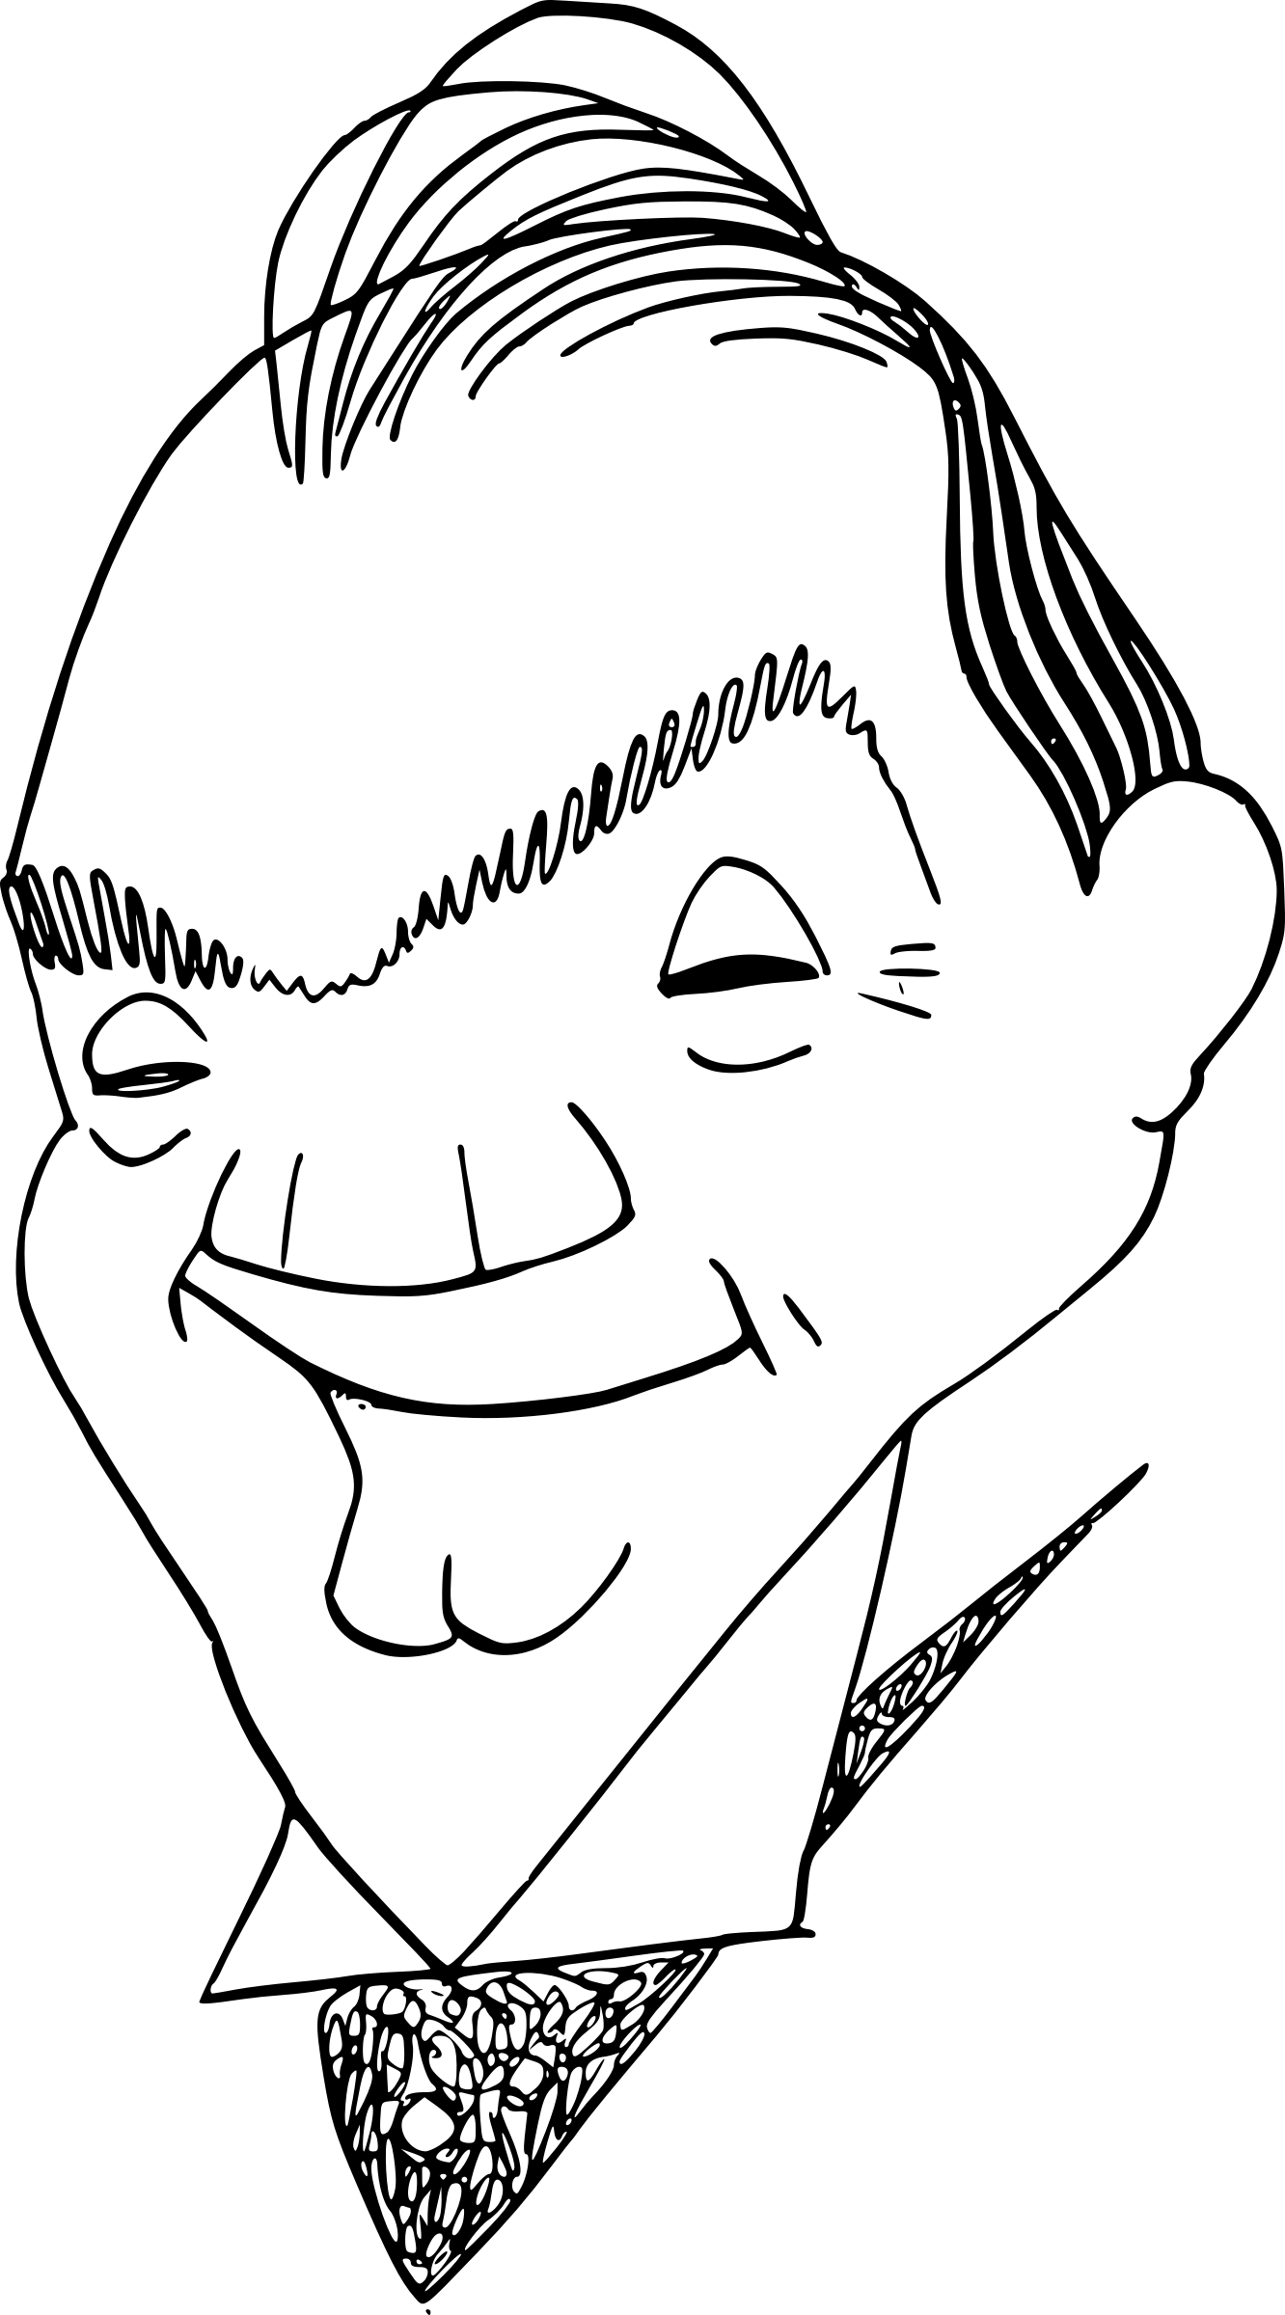

Lesson 1-Story  
Guard Face

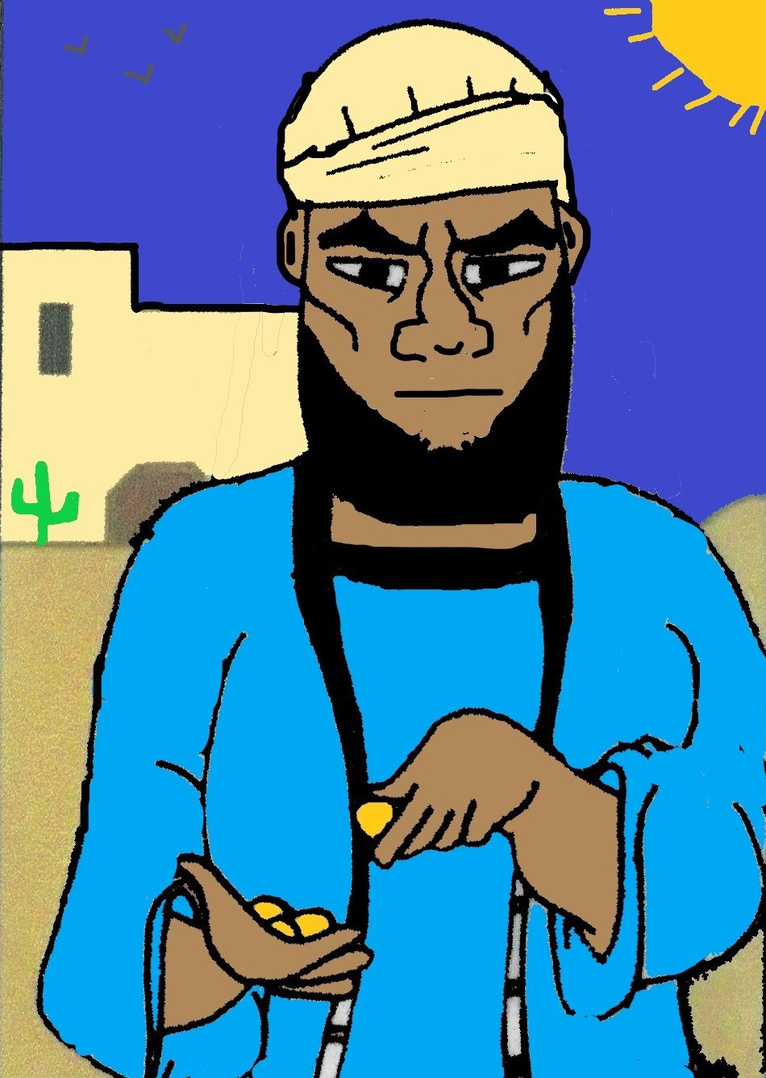

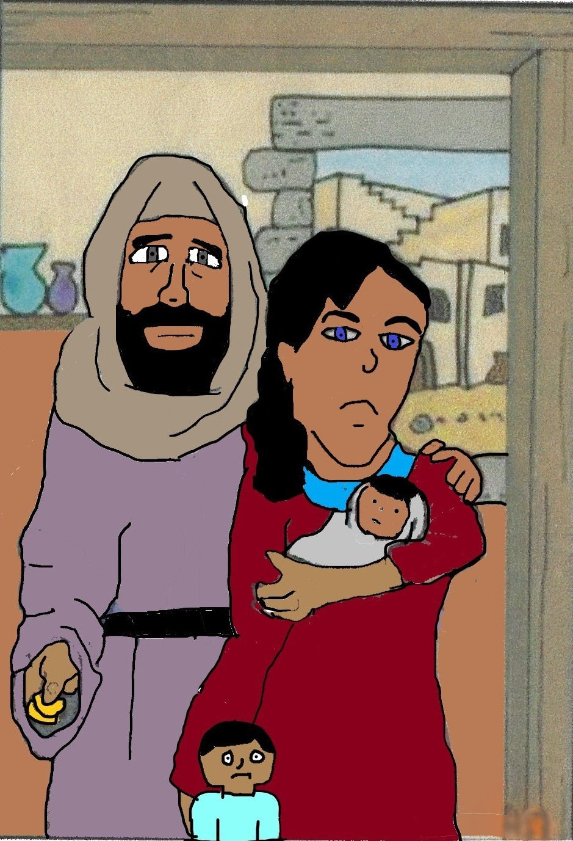

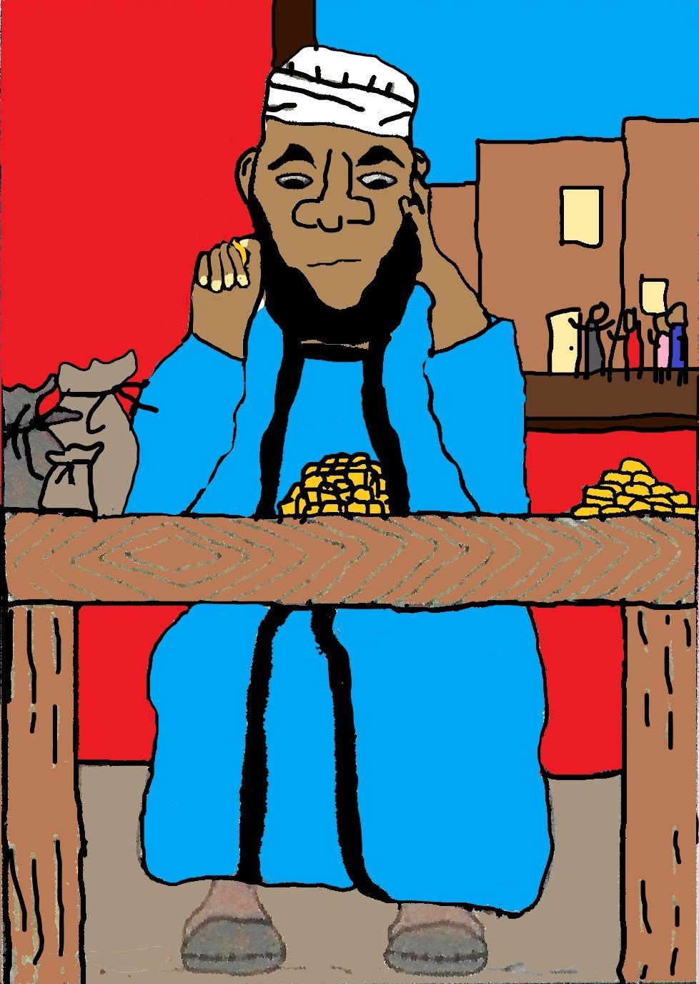

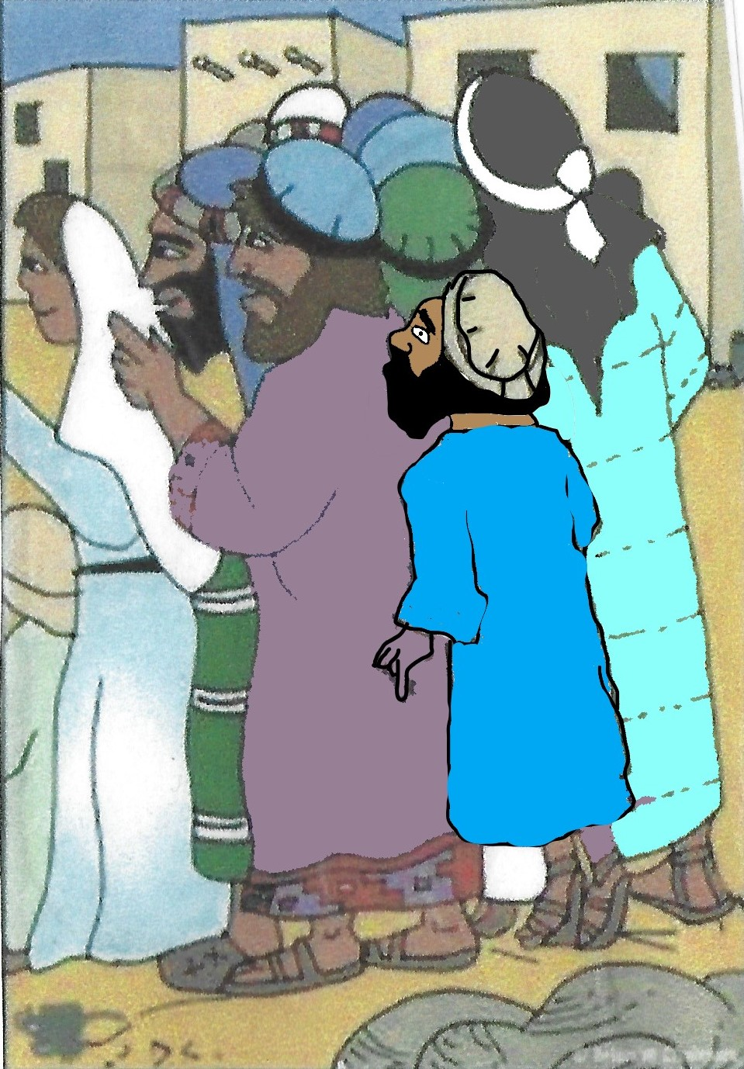

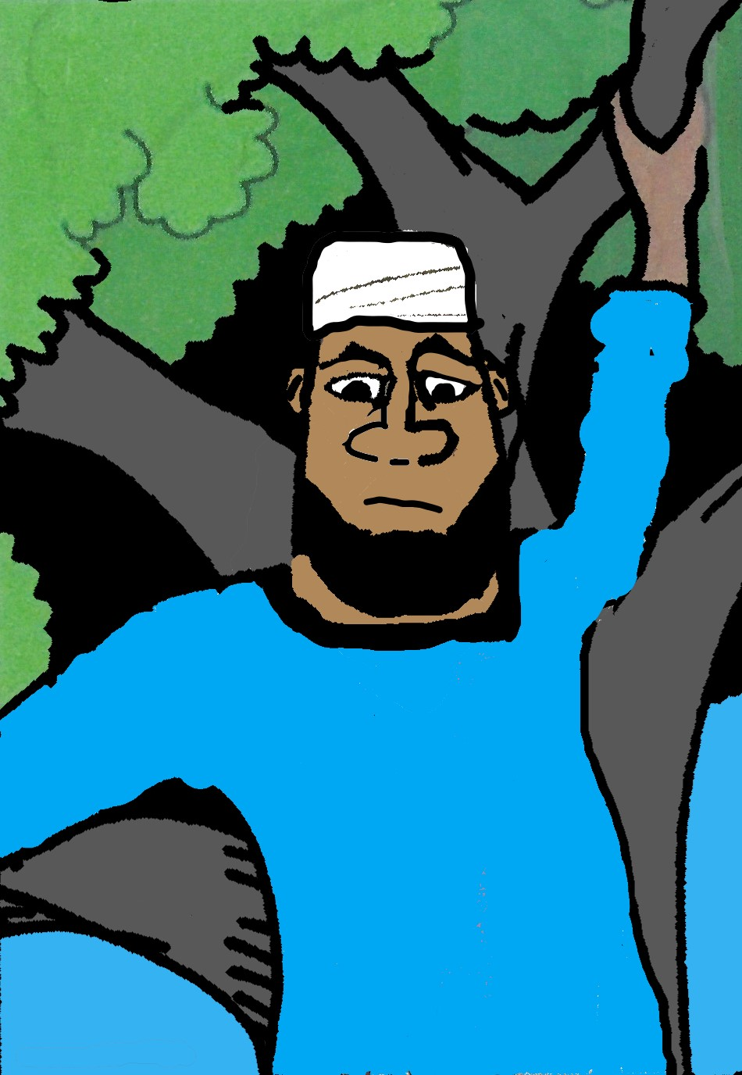

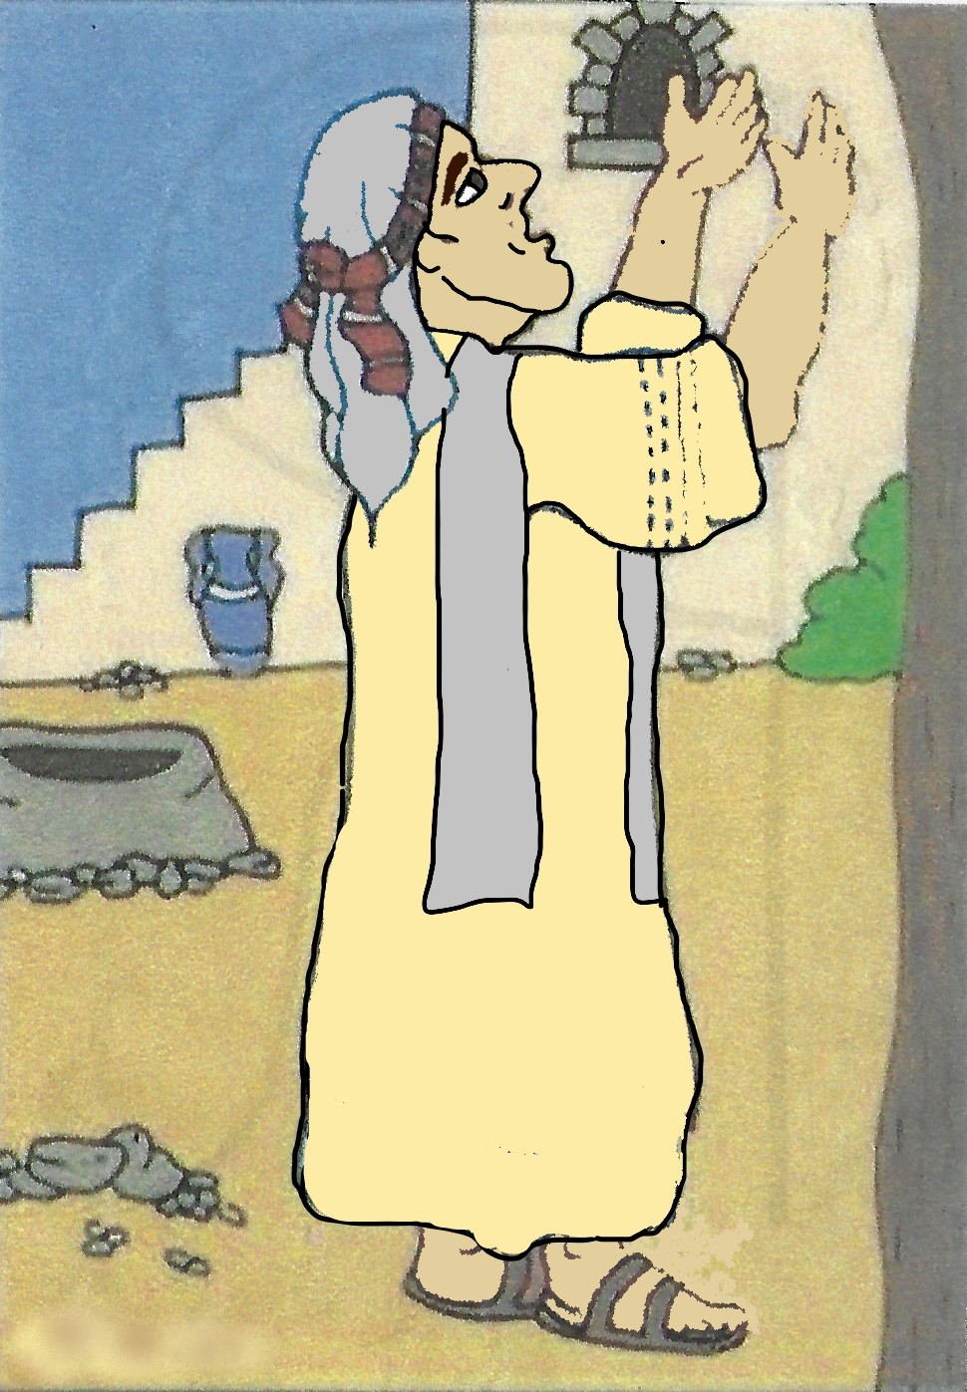

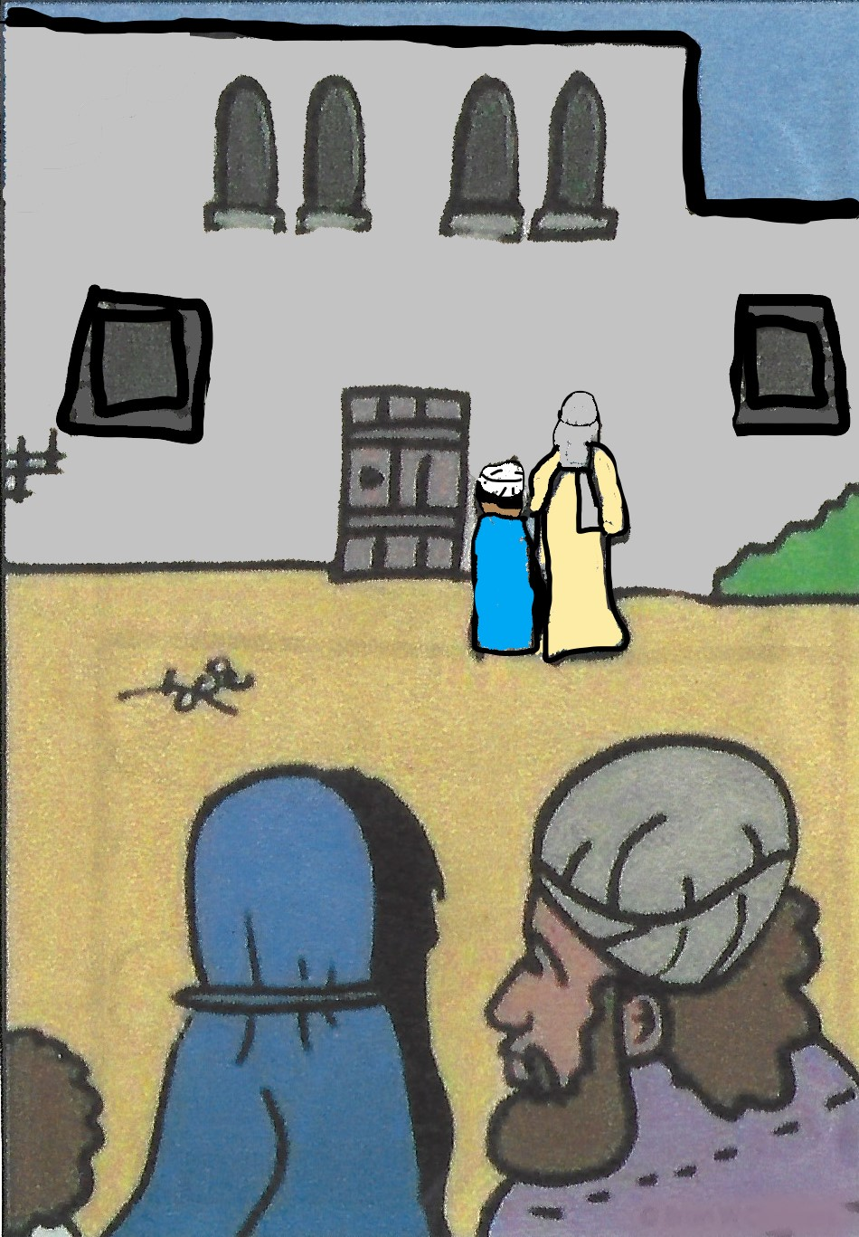

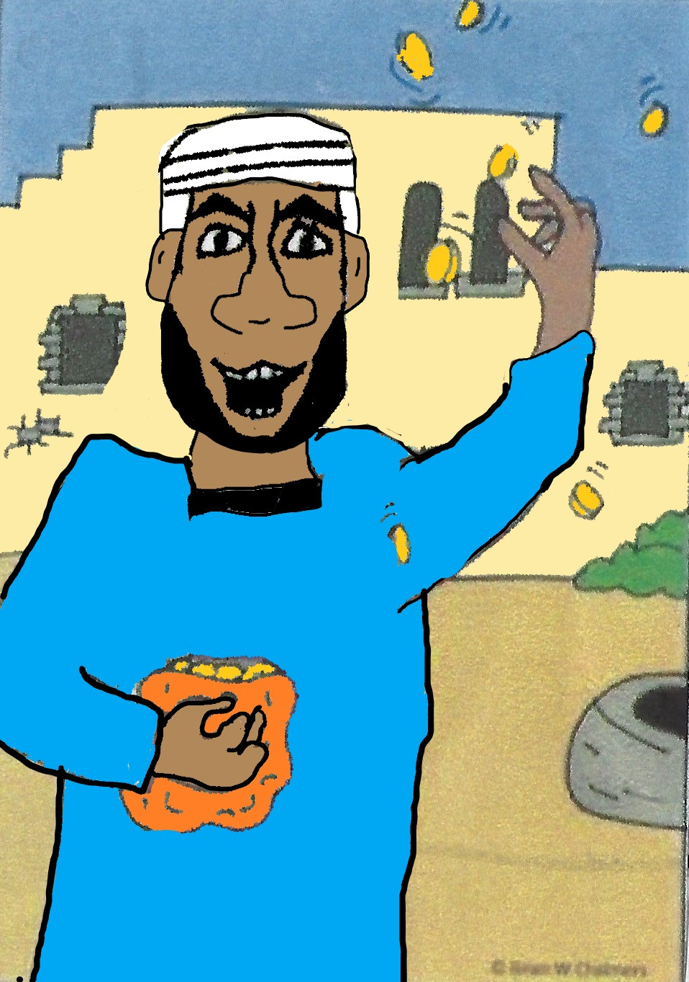

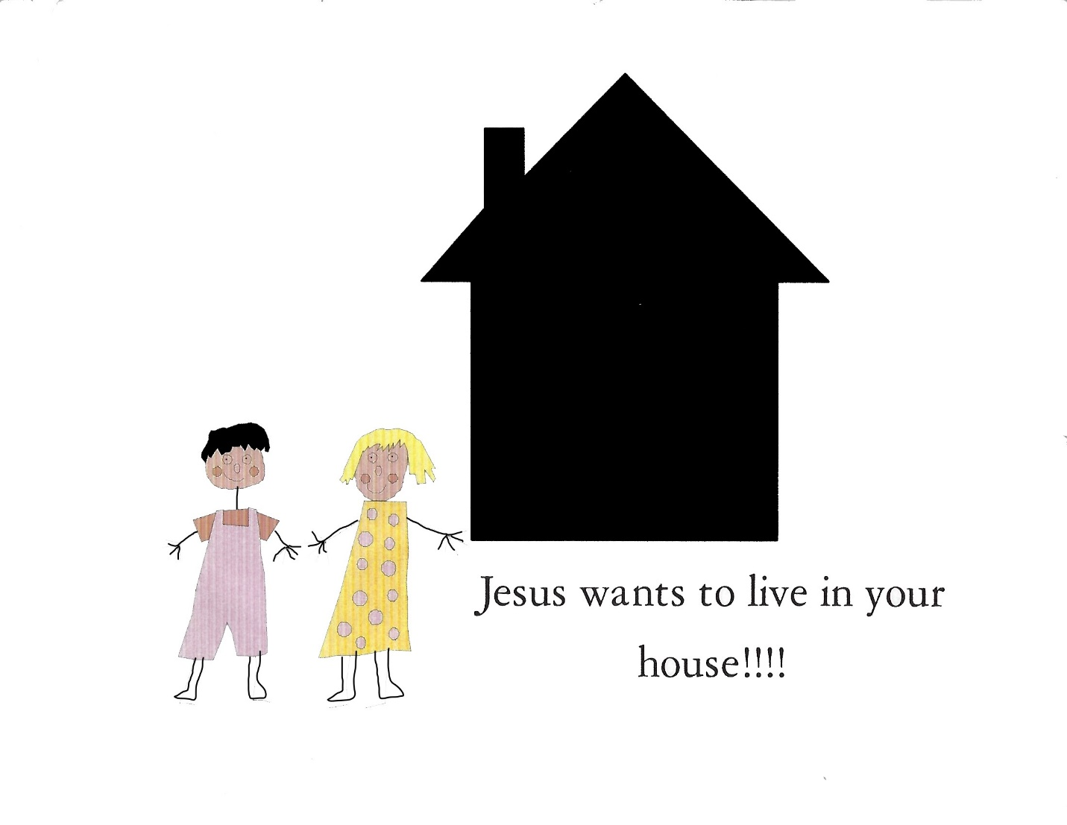

**The Story of Zacchaeus Up a Tree**

**Story Card One**

There are two things you should know about the man in our Bible story today: Zacchaeus was a very little, short man. He was very rich and nobody liked him. Whoops, that’s three things. Oh, well.

**Story Card Two**

Nobody liked Zacchaeus very much because he got rich taking money from the poor people and giving it to the Romans (they were the rulers at this time). He collected money for the Romans. They called it collecting taxes. Some of the money he took from the poor people he gave to the Romans, but lots of it he kept for himself-that’s how he got very, very, rich. Remember he was a very rich man, a very little short man, and he had no friends.

Story Card Three

One day as Zacchaeus was sitting, counting his money 100, 101,102,103,104,105, he heard a loud noise coming down the road.

Story Card Four

Zacchaeus ran up to the edge of the crowd and stood on his tiptoes to see what the big deal was. But all he could see was the backs of people’s heads. He tried jumping up and down. He bounced from side to side-but he still couldn’t see. On one lucky bounce he saw the man at the center of the crowd, but everyone wanted to see Jesus and they wouldn’t let him through. What could he do? He wanted to see Jesus too!

Story Card Five

Zacchaeus didn’t know what to do. He turned around and saw a big tree growing right beside the road Jesus was walking on. He had an idea! He ran ahead and climbed up into that tree. He didn’t care if he looked silly or not. He wanted to see Jesus.

Story Card Six

Sure enough, Jesus stopped right under that tree. He looked up and there was Zacchaeus peeking through the branches. “Zacchaeus!” Jesus said to him, “Hurry down from that tree, I must stay at your house today.” “How does he know my name?” Zacchaeus thought to himself. “But he does, he knows my name and he wants to come to stay at my house.”

Story Card Seven

When his feet hit the ground he was so happy, he almost did a dance! That’s what Jesus does to people-he makes them happy. Jesus laughed and put his arm around Zacchaeus’ shoulder and together they started towards Zacchaeus’ house.

Story Card Eight

But the people in the crowd were not so happy. They began to grumble about Zacchaeus. “This man is a sinner!” said one woman. “He cheats and steals,” said another man. He isn’t good enough for Jesus to stay at his house.” Zacchaeus heard what the people were saying and he knew it was true. He felt really bad. So, he said “Listen, I will give half of everything I have to the poor, and if I have cheated anyone, I will give them back four times as much. He started giving money back to the poor people.

Story Card Nine

Jesus was going to be a guest at Zacchaeus house. What do you do when company comes? You clean your house up.

That’s what Zacchaeus did. Only, he cleaned himself up on the inside first. He repented of the bad things he had done and made things right with the poor people. He was so happy that Jesus wanted to come to his house; he wanted to make Jesus happy too. Jesus was happy with what he had done.

Zacchaeus was a little man, but now he felt ten feet tall, because his heart was clean. And you know what? Jesus knows you too, he knows you by name, just like he knew Zacchaeus. Jesus wants you to repent, be baptized in Jesus Name and be filled with the Holy Ghost. Let’s all bow our heads and pray together.

**Card One: Three Hebrew Children**

Our Bible story today is about three brave Hebrew young men. Their names were Shadrach, Meschach and Abednego. Those are funny names aren’t they? Can you help me say them?

Shadrach, Meschach, and Abednego. That was very good!

**Card Two: Three Hebrew Children**

One day King Nebuchadnezzar, (another funny name) made a very big statue of gold and told everyone to bow down and worship it. The people who did not bow down to the statue would be thrown in a fiery furnace (that’s a big oven). Almost everyone was afraid and bowed to the idol, just as they were told.

**Card Three: Three Hebrew Children**

Now there were three young men, Shadrach, Meshach, and Abednego loved God very much and refused to bow down to the golden idol. They only worshipped and bowed down to the one true God of Abraham and Isaac and Jacob. The king became very angry because they would not bow down to his statue. He had Shadrach, Meschach and Abednego tied up and thrown into the centre of the fiery furnace.

**Card Four: Three Hebrew Children**

After awhile the king looked into the fire and saw not three, but four people in the fire. The fourth person was like the Son of God. The three Hebrew children were protected in the fire, because of their faithfulness and trust in the Lord.

**Card Five: Three Hebrew Children**

King Nebuchadnezzar was very surprised and called them to come out of the fiery furnace. Not even a hair on their bodies was burnt and their clothes didn’t even smell like smoke. Can you believe that? That was a miracle. The king said that only God could save people from the fiery furnace and he ordered that no one could speak bad of the God of Shadrach, Meshach and Abednego. The king proclaimed, “There is no God like the God of Shadrach, Meschach and Abednego.

